Awards of recognition, 2020
It is INTDS tradition to award the INTDS members for their outstanding achievements in development of the target preparation techniques and/or for service to the Society. Traditionally the award of recognition is presented during the conference held every second year.
Unfortunately the awards of 2020 could not be handed during the conference banquet as due to COVID-19 pandemic lockdowns there was no conference and even less, traditional banquet. Nevertheless, the voted awards were delivered to the awardees and later celebrated during the virtual membership meeting. This year we are proud to address our gratitude to:

Roger Eykens  JRC-EU, Geel, Belgium   | John Greene  Argonne National Laboratory, Chicago, USA   | John Stoner  Arizona Carbon Foil CO, Inc, Arizona, USA  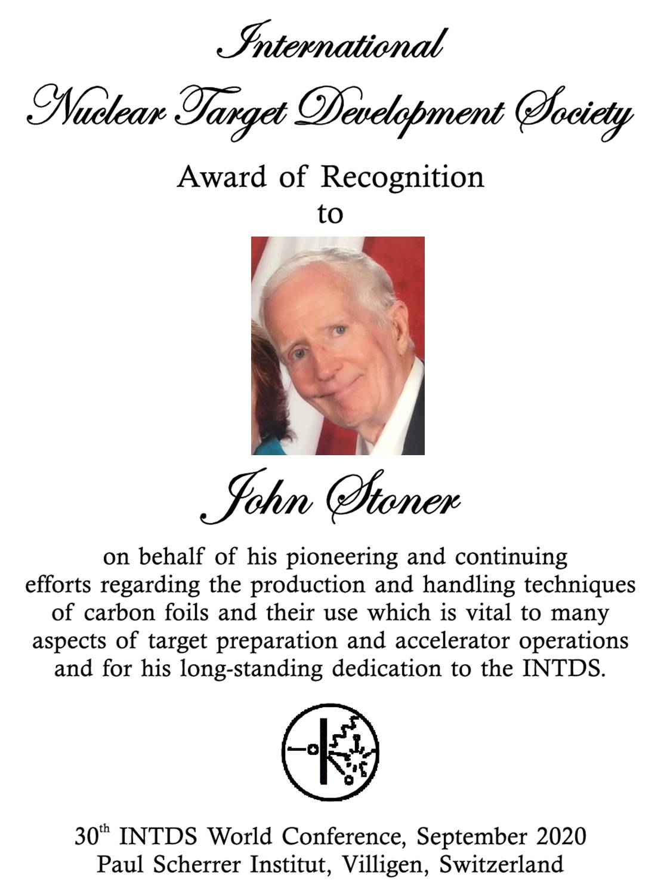

CONGRATULATION!

