Awards of recognition, 2010
It is INTDS tradition to present, during the conference banquet, the award of recognition for outstanding achievements in development of the target preparation techniques or for service to the Society to person or persons nominated by the Board of Directors.
As I said on Monday at the opening of this year's Conference our Society was established in 1975 and already in 1982 the first award was presented to Dan Riel, the founding father and the first president of the INTDS. Since then during nearly every conference the awards were presented and full list of awardees can be found on our web site.

This evening, at a banquet of 25th INTDS World conference I have a great pleasure to announce that the INTDS Award of Recognition goes this year to:

Bill Lozowski  Indiana University, Bloomington, USA  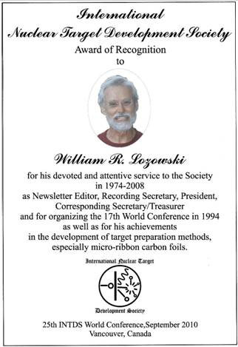 | and | Isao Sugai  KEK, Tsukuba, Ibaraki, Japan  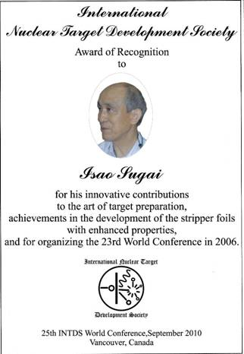

CONGRATULATION!

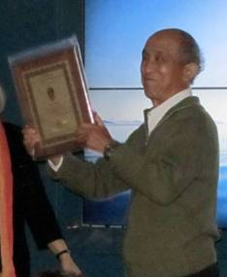
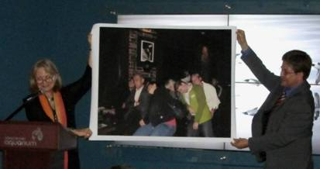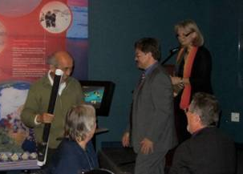

published: 25 October 2010

