Award of recognition, 2014
It is INTDS tradition to present, during the conference banquet, the Award of Recognition for outstanding achievements in development of the target preparation techniques or for service to the Society to person or persons nominated by the Board of Directors.

This time the Society’s Award went to

David Gilliam
from National Institute of Standards and Technology, Gaithersburg, USA.

Congratulation!!

It was handed, unfortunately in absentia, by the INTDS President at the banquet of the 27th INTDS World conference held on the cruise on the Tokyo-bay.

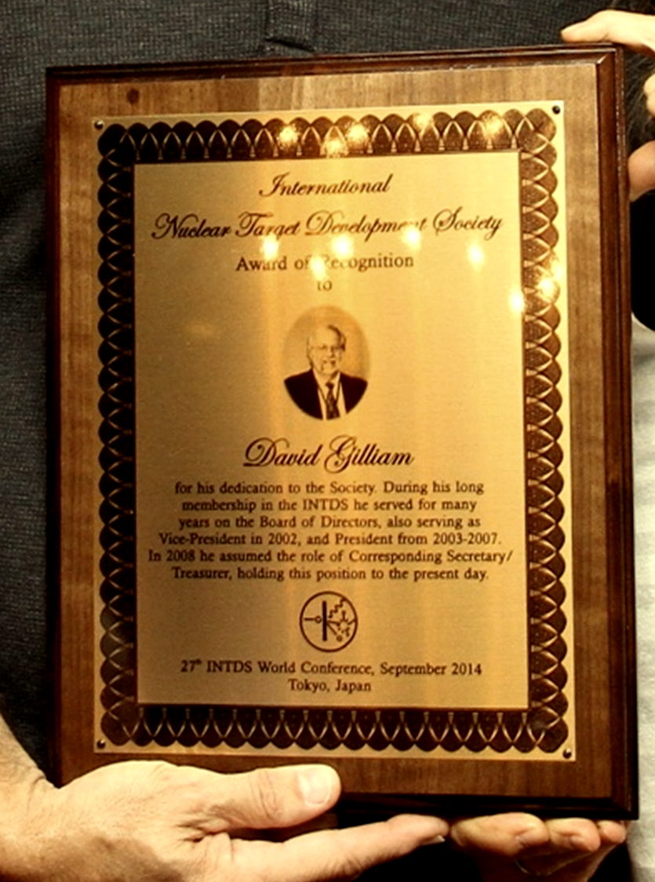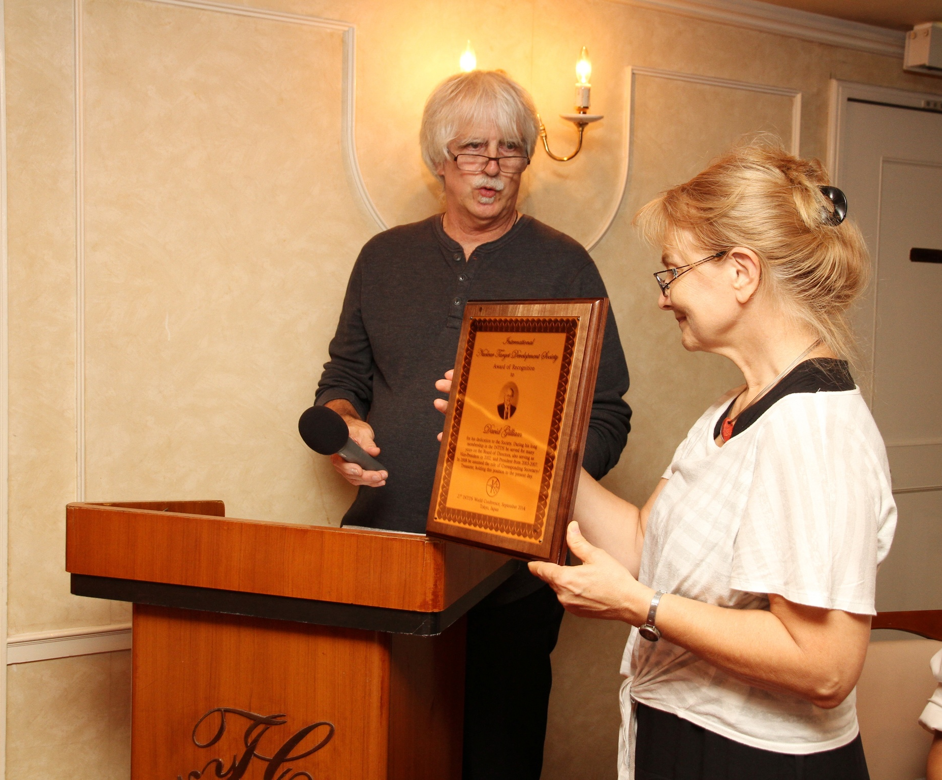

Posted: July 2015

