Award of recognition, 2016

Following the long lasting INTDS tradition of handing during our biennal meetings the Award of Recognition for outstanding achievements in development of the target preparation techniques or for service to the Society to person or persons nominated by the Board of Directors, the Society’s Award was handed to

Anna Stolarz
from Heavy Ion Laboratory, University of Warsaw, Poland

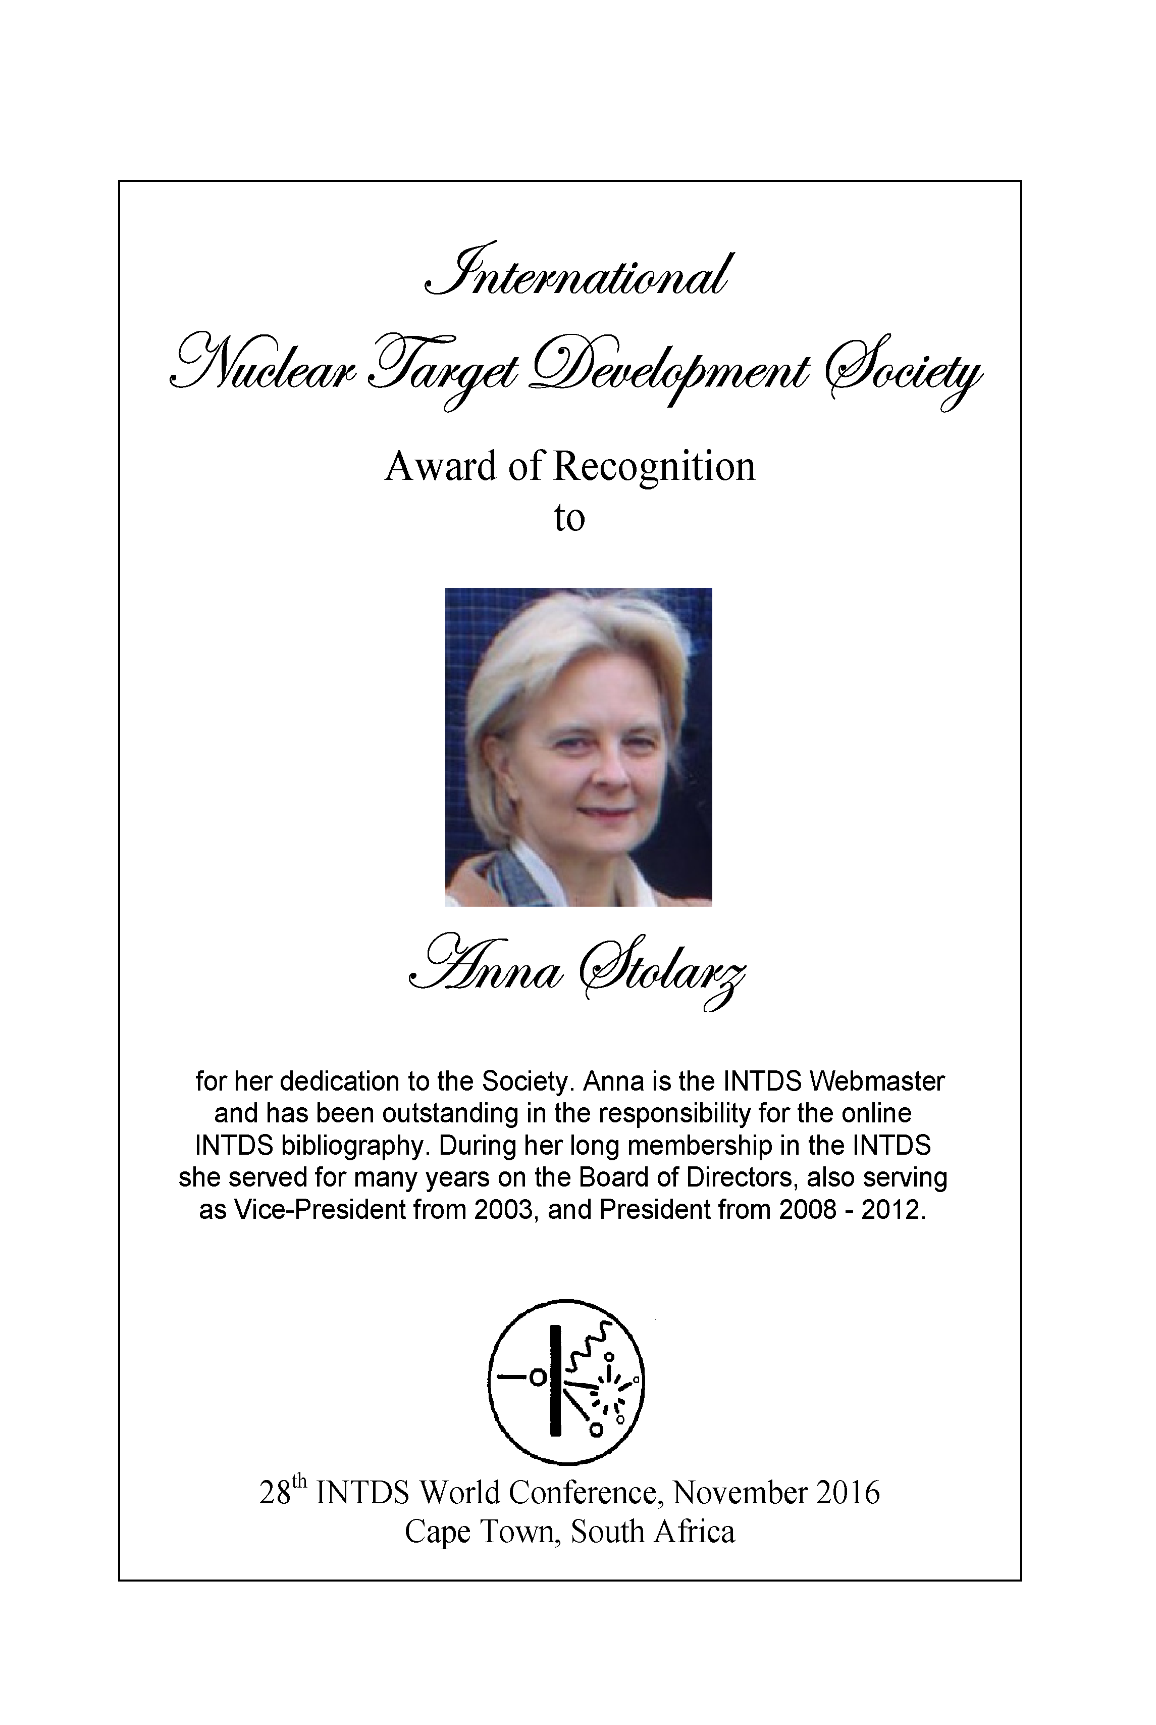

Congratulation!!

It was handed by the INTDS President at the banquet of the 28th INTDS World conference
held in an old vineyard Nooitgedacht Estate, close to Stellenbosch.

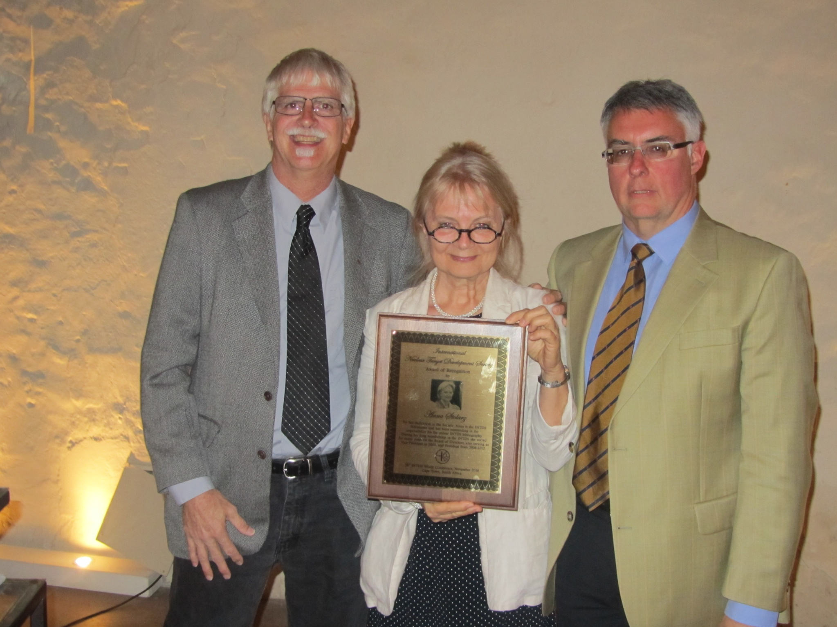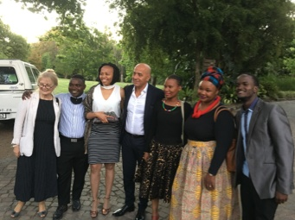

Published: December 2016

